MRI Processing Instructions

Modification History

|  |  |  |
| --- | --- | --- |
| Date | Name | Modifications |
| 16-Nov-17 | Tod Flak | Created |
|  |  |  |

# Dummy’s Guide for quick processing of new MRI Session data

1. Double-click “MRI Processing” shortcut on the Desktop 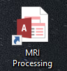
2. 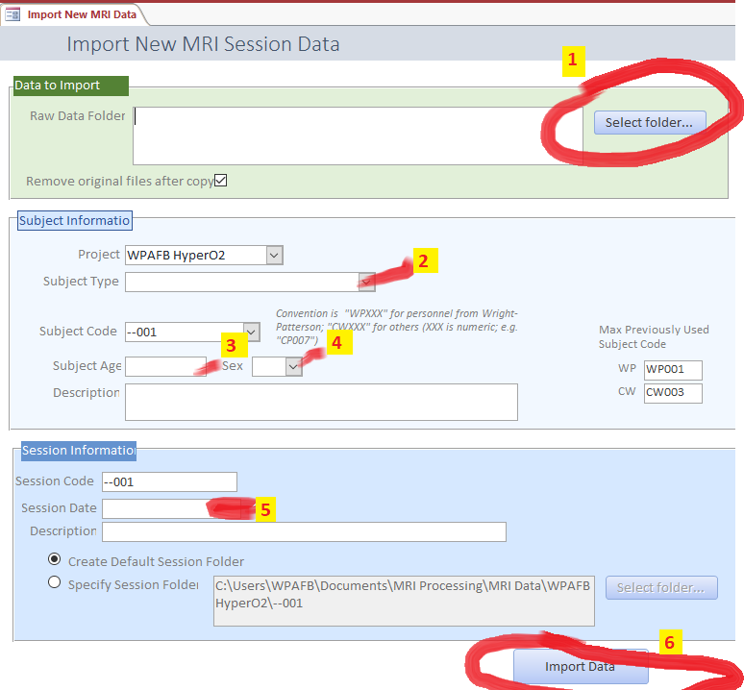On left Navigation Pane, double-click “Import New MRI Data” 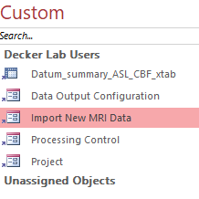
3. On the form “Import New MRI Session Data”, working from top to bottom, do these things:
   1. Click button “Select Folder…” to select the folder where you have the raw MRI images (IMA files)
   2. Select the Subject Type  
      After selecting, observe the suggested Subject Code and Session Code… modify if necessary
   3. Enter Subject Age
   4. Select Subject Sex
   5. Select Session Date  
        
      Obviously, you may enter description of subject and/or session if you wish.
   6. 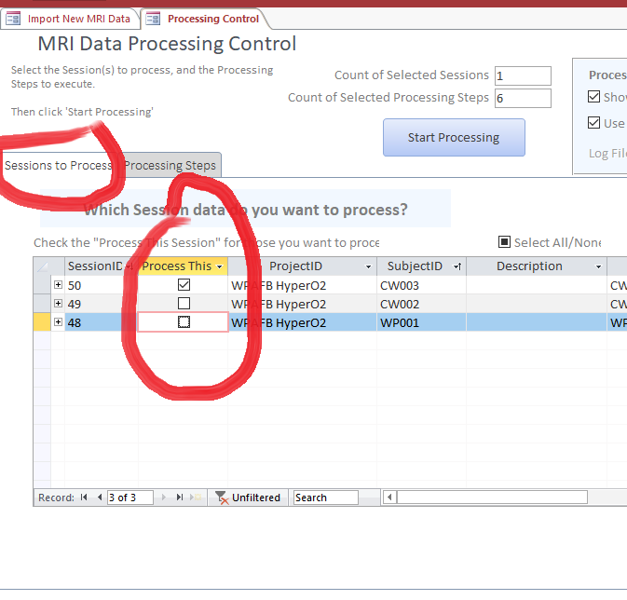Click “Import Data” button  
      Answer “OK” and “Yes” to open the Processing Control form.
4. On the form “MRI Data Processing Control”, do these things:
   1. On the tab page “Session to Process”, confirm that the only selected session (by the check mark in the “Process This Session” column) is the one Session you just imported.
   2. 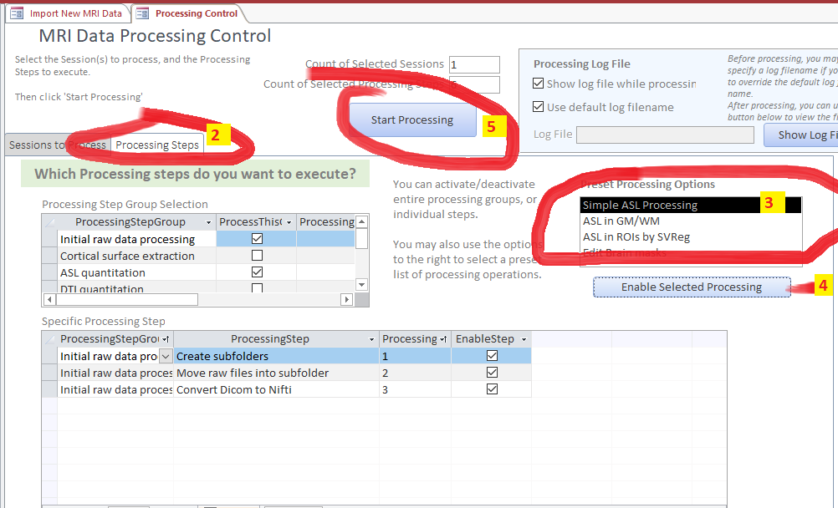Click on the tab page “Processing Steps”.
   3. On the list “Preset Processing Options”, highlight the row “Simple ASL Processing”
   4. Press the button “Enable Selected Processing”
   5. At the top of the form, press the button “Start Processing”
   6. Assuming that the processing completes without error, click “OK” on the "Processing Complete" message.
   7. When prompted “Would you like to open the ASL Data Crosstab view”, answer “Yes”

# Introduction

We have created a system for processing MRI data, which incorporates several different software packages control by a central software system. The central control system is implemented in a Microsoft Access database. The processing results are also stored in a MS Access database.

This system was created initially for processing ASL data, but it is easily adaptable to processing other varieties of MRI data, or even non-MRI data. The MS Access database software implements a processing flow mechanism which can call external software packages, and which is configurable to perform different types of analyses.

# Basics about using MS Access

## What is MS Access

Microsoft Access (MS Access) is actually a combination of two things:

1. A relational database system (where data is stored in tables, similar to an Excel worksheet); and which includes the ability to build complex queries, reports, etc.
2. A user interface, which includes customizable forms, with integrated code.

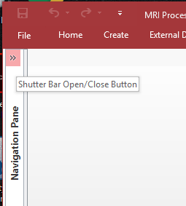In our implementation, we actually have two MS Access files – one file stores all the data (“MRI Processing_be.accdb”) ; another file contains the user interface forms, and processing code (“MRI Processing.accdb”). Generally, you will only need to open the “MRI Processing.accdb” file.

## Finding what you need in Access

MS Access has a Navigation bar on the left side of the screen. It might be minimized when you open the database. In that case, just click the “>>” icon to show the Navigation Pane. You might like to minimize it later to get more screen space.

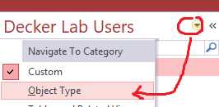I have set up a Custom navigation pane called “Decker Lab User”. This list shows only the minimal necessary objects to accomplish basic data analysis. If you ever need to see all of the objects in the database, click the down arrow near the top of the navigation pane, then select “Object Type”. You will then see all objects, grouped by type: Tables, Queries, Forms, Reports, Macros, Modules. To revert to the custom view, simple click that same down arrow and select “Custom”

## Interacting with data tables

There are some important concepts to know which looking at data in MS Access data tables. These points apply equally whether looking at data in a customized form, or looking at data directly in a data table.

* 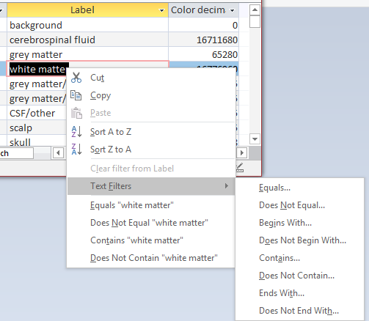You can easily sort the rows by right-clicking on any data cell, and select “Sort …” (either “Sort A to Z” for textual data, or “Sort Smallest to Largest” for numeric data, etc.). Unlike in Excel, the sorting is automatically applied to the entire table – that is, there is no need to select all the columns… data in each row is always kept together.
* 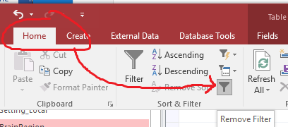You can easily filter data by right-clicking on any data cell, and selecting one of the filter options (e.g. one of the preset filters like “Equals ‘white matter’; or one of the generic filters like “Begins with…” where you can then specify the filter criterion). After filtering, you can restore to viewing all records by using the menu option “Home” then click the icon to “Remove Filter” (or click the big “Filter” funnel icon for even more options.
* If you start typing into a cell (either on purpose, or just accidentally hitting a key on the keyboard), you will start editing the data in the record!! Beginning users often do not realize this, and will inadvertently edit data. Some custom forms are specifically designed to prevent users from accidentally editing data, so using those forms is safer than directly opening the 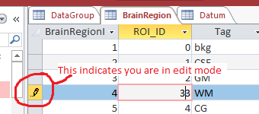underlying data tables.  
  In general, you should be aware that when you start to edit data, an icon at the left edge of the row will turn to a little “pencil” as shown here. As soon as you click your mouse cursor off of that record, your edits will be committed (i.e. saved) to the database table. If you want to undo (i.e. 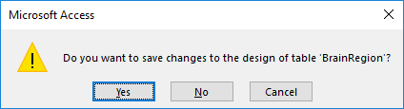not commit) your changes, you can press the Escape (Esc) key.
* When closing a table view or form, you may get a message such as “Do you want to save changes….”. You may get this even if you didn’t think you made any changes. It is not asking if you want to save changes you made to the data (because data changes are committed immediately after you click outside the record you edited). Instead, it believes you have made some change to the “view”, such as changing a filter or sort, or even changing the width of a column. It is up to you to decide if you want to save the change or not. Typically, I advise to select “No” unless you made some view change that you really want to persist for the next time you open that same object (for example, you always want a certain column to be some particular width).

# Import New MRI Session data

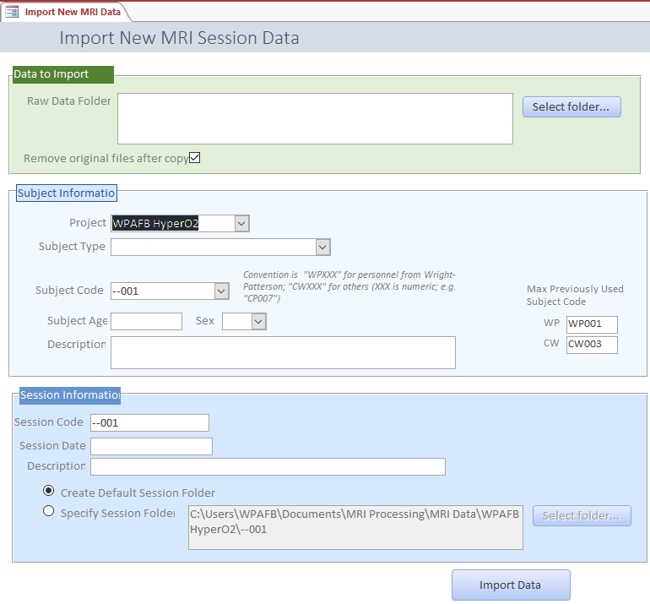To start the process, in the Navigation Pane, click the icon for the form “Import New MRI Data”. You will see a form like this.

In the “Data to import” section, select the folder containing the MRI image files that you wish to import. The images in the selected folder will be copied into a new folder in the “MRI Data” subfolder.

If you check the option “Remove original files after copy”, the source folder will be MOVED instead of being copied; if you uncheck that option, the source files will be copied, and the original files left in place.

In the “Subject Information” section, first select the “Subject Type”. Doing that will automatically populate the “Subject Code” and “Session Code” fields with suggested names, based upon the maximum subject code already existing for that Subject Type. You are free to edit the “Subject Code” and “Session Code” if the suggested values are not to your liking. These values of “Subject Code” and “Session Code” are not critical for the functioning of the data analysis, but should be chosen to allow you to easily understand what data you are looking at later in the process.

In the “Session Information” section, set the Session Date – when you click in the field, a Date Picker icon will appear to allow you to select the date.

Generally, it is fine to use the option “Create Default Session Folder”, to create the data folder that is suggested in the greyed-out text box. But if you have a need to change that value, simply choose the option “Specify Session Folder” and use the button “Select folder…” to set the session folder.

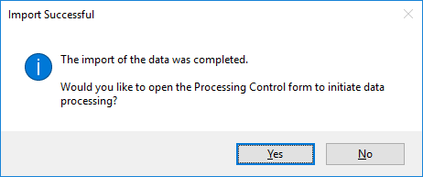Finally, click the “Import Data” button. You should see several message boxes, informing you that the Subject and Session records were created, and then that the data files were imported.

If all goes correctly, you should see a “Import Successful” message, with an offer to open the Processing Control form to initiate data processing.

When processing is complete, you may like to close all of the log windows. You can do this easily by right-clicking on the command windows icon in the taskbar and selecting “Close All Windows”.

## Structure of data folder

The imported MRI data is placed in a folder on your computer, at a location determined by several setting in the database (for more information, see setting “Data root path” on table “Setting_Local”; and setting “DataFolderRoot” on table “Project”).

A new folder is created for imported MRI dataset; the name of the folder is the Session Code defined when you imported the data.

The import process creates multiple subfolders, as shown here. Initially, all of the folders are empty, except the “raw” folder, which contains all of the imported MRI images.

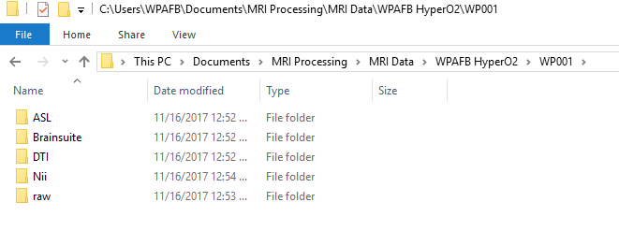

# Data Processing

Data processing is controlled by the database code, which launches external processing commands in a specific sequence. The configuration of the processing steps is controlled by two tables:

* **ProcessingStepGroup**: a list of the high-level processing groups, such as “Initial raw data processing”, “ASL quantitation”, etc.
* **ProcessingStep**: each ProcessingStepGroup has multiple ProcessingStep records, each of which invokes a discrete part of the process.

You are in control of which processing steps get invoked. You can enable/disable entire ProcessingStepGroups or individual ProcessingStep.

The system keeps track of

In the Navigation Pane, select the shortcut “Processing Control” to open the form “MRI Data Processing Control”

If you want to terminate data processing while Matlab code is running, you can try to select the Matlab icon from the Taskbar, right-click, and select “Close Window”. If that doesn’t work, you can also use Task Manager to find the Matlab process, right-click, and select “End Task”.

# View Results

# Advanced

## Database Schema

## Processing Details

## Settings system